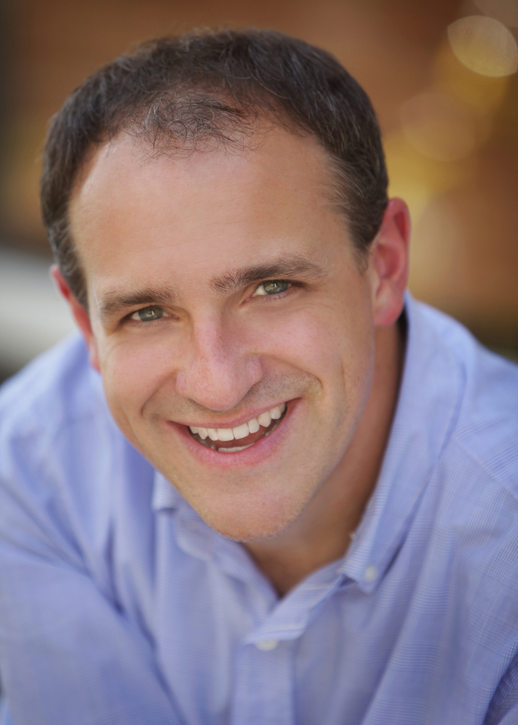

120 Aikman Pass (501) 366-4142

Conway, AR 72034 fritzges@uca.edu

**PERSONAL DETAILS**

HEIGHT: 5'7" EYES: Hazel VOICE: Bass/

WEIGHT: 165 HAIR: Brown Baritone

**FILM/COMMERCIAL/INDUSTRIAL/ACTING CREDITS**

*Sympathy Pains* Danny (lead)Daringly Dull Productions Feature film

*Table at Luigi’s* Stephen (supporting) Daringly Dull Productions Feature film

*Simmons Bank* Talent 360 Productions Regional commercial

*Southland Park Gaming* TalentWaymack and Crew Regional commercial

*Furniture Factory Outlet* Talent Waymack and Crew Regional commercial

*Arkansas Parks & Tourism* Talent Jones Productions Regional print

*The Register*  Mr. Dias Lyle Arnett Prod. Short film

*Comm. With Sensitivity* Peter UCA Department of Film Industrial

Conway Regional Health

**RADIO/VOICEOVER CREDITS**

Capitol Federal Savings Bank - 2014 (regional radio commercial) Lucky Dog Audio (Little Rock)

JD Bank (regional radio commercial) Lucky Dog Audio (Little Rock)

Capitol Federal Savings Bank – 2013 (regional radio commercial) Lucky Dog Audio (Little Rock)

Agrotain (regional radio commercial) Lucky Dog Audio (Little Rock)

Sport Clips (national radio commercial) Lucky Dog Audio (Little Rock)

Arkansas Specialty Orthopaedics (local radio commercial) Lucky Dog Audio (Little Rock)

The Old Grey Lady (voiceover work for award-winning documentary) UCA Department of Film

**STAGE ACTING CREDITS**

*Romeo and Juliet* CapuletArkansas Shakespeare Theatre Rebekah Scallet

*Fiddler on the Roof Constable* Arkansas Shakespeare Theatre Jeremy Williams

*Love’s Labor’s Lost* HolofernesArkansas Shakespeare Theatre Rebecah Scallet

*Man a la Mancha* The Barber Arkansas Shakespeare Theatre Steven Flaa

*Much Ado About Nothing* Don Pedro Arkansas Shakespeare Theatre Kristine Holdtvet

*Julius Caesar Artemidorus* Arkansas Shakespeare Theatre Robert Ramierez

*Midsummer…Dream Snug* Arkansas Shakespeare Theatre Robert Quinlan

*Merry Wives of Windsor Master Page* Arkansas Shakespeare Theatre Dan Matisa

*Two Gentleman of Verona* Duke Arkansas Shakespeare Theatre Rebekah Scallet

*Hamlet*  Osric Arkansas Shakespeare Theatre Robert Quinlin

*King Lear* Cornwall Arkansas Shakespeare Theatre Rebekah Scallet

*Enchanted Tales* Narrator Conway Symphony Orchestra Israel Getzoff

*Children’s Concert* The Adventurer Arkansas Symphony Orchestra Philip Mann

*Rock Me Amadeus* Mozart Conway Symphony Orchestra Israel Getzoff

*The Composer Is Dead* The Inspector Conway Symphony Orchestra Israel Getzoff

*Midsummer…Dream* Flute/Thisbe Arkansas Shakespeare Theatre Jeffey Frace

*Romeo & Juliet* Paris Arkansas Shakespeare Theatre Jeffrey Frace

*The Tempest* Gonzolo Arkansas Shakespeare Theatre David Alford

*As You Like It* Touchstone Walton Arts Center Roger Gross

*Angels In America* Roy M. Cohn University Theatre (Arkansas) Chuck Gorden

*A Lie of the Mind* Jake Starr Theatre David Pickens

**TRAINING**

M.F.A. in Drama (Acting), University of Arkansas, 2000

B.A. in Fine Arts (Theatre Concentration), Bethany, WV, 1996

**TEACHING CREDIT**

**CURRENT EMPLOYMENT**

*Associate Professor of Theatre* (Acting, Directing, & Voice) / 2002 - present

University of Central Arkansas, Conway, AR

**SPECIAL SKILLS & STRENGTHS**

* stage combat/SAFD unarmed certification
* juggling
* select dialects & triggers
* vocal coaching for the stage
* directing (& theory)
* Shakespeare
* farce
* carpentry & lighting
* broad physical characterization (commedia)